VENANGO MUSEUM of ART, SCIENCE & INDUSTRY
MEMBERSHIP FORM

Name (Please print)______________________________________________________________________

Address_______________________________________________________________________________

City_____________________________State_________Zip____________Phone_____________________
Payment Options:
( ) Enclosed is my check payable to Venango Museum in the amount of $_________________________
( ) Enclosed is cash in the amount of $_____________________________________________________
( ) Charge card number_________________________________ 3 or 4 digit number on back________
Expiration Date______________________________ Billing Zip Code_______________________
Annual General ( ) College Student $5 ( ) Sr. Citizen $10
Memberships ( ) Senior Citizen Couple $15 ( ) Individual $15
( ) Family $25 ( ) Supporting $26-99

Annual Sustaining ( ) Friends Circle $100-249 ( ) Directors Circle $250-499
Memberships ( ) Trustees Circle $500-999 ( ) Presidents Circle $1,000-9,999
( ) Lifetime $10,000 - $49,999 ( ) Founders Circle $50,000 +

270 Seneca Street, Oil City, PA 16301
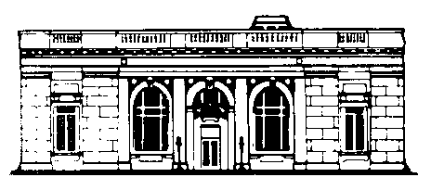
(814) 676-2007 E-mail: venangomuseum@verizon.net
Website: venangomuseum.org

